A. Qualitative analysis: Flame tests, test for cations and ammonia
- A student has three different samples of chemicals. They know that one contains lithium, one contains potassium and one contains calcium. Describe the test she could do to determine which chemical contains which metal. (6)
Any three from: (a diagram is acceptable)
Heat metal wire [1] dip in chemical [1] put in roaring [1] Bunsen flame [1]
Lithium – red [1]
Potassium – lilac [1]
Calcium – orange-red [1]

- The student has another sample that they know contains copper, however when they carry out the flame test they get a yellow colour rather than the expected green. Explain why this happens. (2)
Chemical is contaminated [1] with sodium [1]

- In a further experiment, two solutions contain aluminium and calcium ions. They are tested with sodium hydroxide solution. Describe the similarities and differences in the results they would get. (3)
Both would give a white precipitate [1] aluminium precipitate would dissolve [1] with additional sodium hydroxide solution [1]

- The following reaction was carried out in a laboratory:
Ca(OH)₂ + 2NH₄Cl → 2NH₃ + CaCl₂ + 2H₂O
Describe how the scientist could test the gas produced to prove its identity. (3)
Damp [1] red litmus paper [1] turns blue [1]
B. Qualitative analysis: Tests for carbonates, halides and sulfates
- A chemist believed that a sample of water contained iodide and sulfate ions. When it was tested with silver nitrate a cream precipitate was produced; when tested with barium chloride a white precipitate was produced. What ions were present in the water? Write balanced symbol equations for the positive results, include state symbols. (6)
Ions identified bromide [1] sulfate [1]
AgNO₃ (aq) + NaBr (aq) → AgBr (s) + NaNO₃ (aq) [1] equation [1] state symbols
BaCl₂ (aq) + Na₂SO₄ (aq) → BaSO₄ (s) + 2NaCl (aq) [1] equation [1] state symbols

- The labels have fallen off three bottles; two contained a sodium salt, the other a copper salt. A scientist wanted to test the chemicals to identify which was which. The copper salt and one of sodium salts contained the same anion.
  - What test should the scientist use to distinguish between the copper and sodium ions? State the expected results. (3)
Flame test [1]; sodium – yellow [1]; copper – blue/green [1]

  - To distinguish between the sodium salts, the scientist added dilute acid; substance B produced a gas which turned limewater milky. She then tested the salts using dilute hydrochloric acid and barium chloride solution; substance A produced a white precipitate. State the identities of substances A and B. Explain your answer. (4)
A – Sodium sulfate (accept sulfate) [1] white precipitate produced [1]
B – Sodium carbonate (accept carbonate) [1] carbon dioxide produced with acid [1]

- Describe how sodium hydroxide solution can be used to show that ammonium ions are present. (3)
Add sodium hydroxide, gentle heating [1]
Gas produced turns damp litmus paper [1] blue [1]

- Explain how a scientist could differentiate between: sodium sulfate, potassium sulfate, potassium iodide and sodium iodide. (6)
Cations:
Flame test; lilac – potassium; yellow – sodium
Iodide ions:
Add dilute nitric acid followed by silver nitrate solution; yellow precipitate – iodide present
Sulfate ions:
Add dilute hydrochloric acid and barium chloride; white precipitate – sulfate present
0 marks | Level 1 (1–2 marks) | Level 2 (3–4 marks) | Level 3 (5–6 marks)
No relevant content | Limited description of one test | Simple description to identify an anion and a cation | Description to identify all ions

- Look at the following results obtained by a student when testing for halide ions. Describe the test carried out and identify the halide ions present. (4)
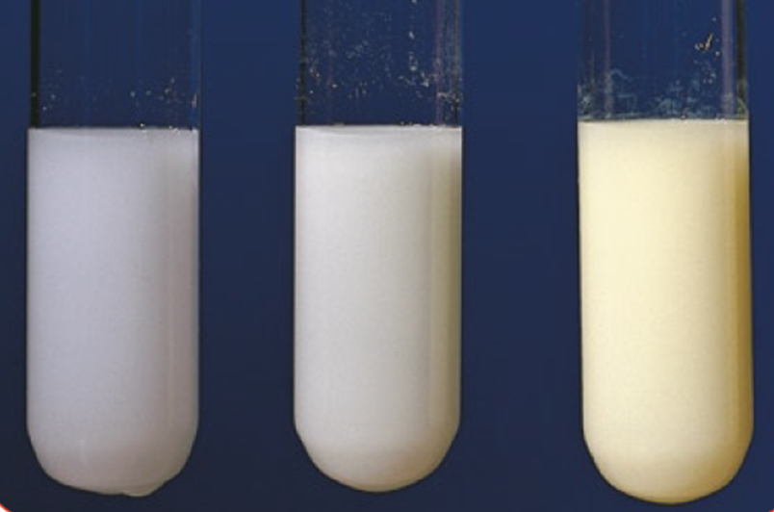
A: White  precipitate | B: Cream precipitate | C: Yellow precipitate
Add dilute nitric acid and silver nitrate [1] A = chloride ions; B = bromide ions [1];
C = iodide ions [1]
C. Qualitative analysis: Flame photometer
- Elements and compounds can be identified using instrumental methods rather than chemical tests. Describe the potential benefits of instrumental methods of analysis. (3)
Any three from: Accurate [1]; sensitive [1]; fast [1]; can be automated [1]

- A scientist used a flame photometer to measure the concentration of sodium ions in a solution in parts per million (ppm). As part of the process she created a calibration curve using known concentrations of sodium ions.
She then tested an unknown sample in the flame photometer and obtained a relative flame photometer signal of 35%.
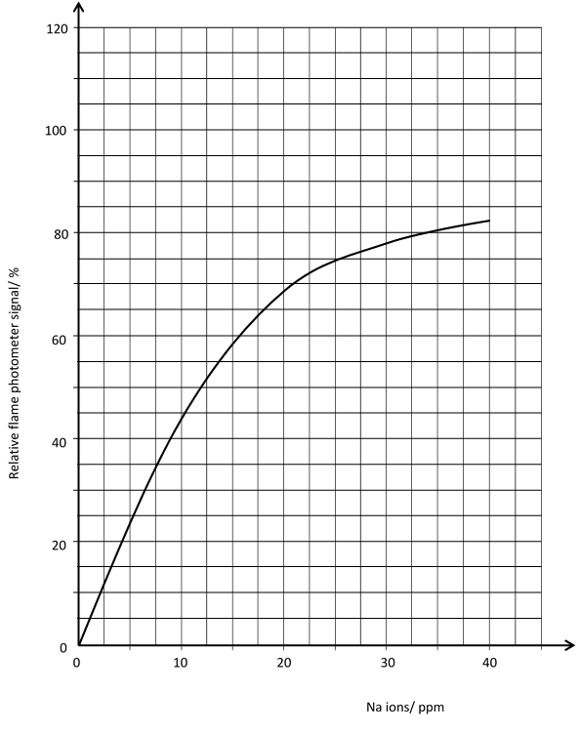

- Use the graph to determine the sodium ion concentration in the unknown sample.
7.5 ppm
- What relative flame photometer signal would you expect to get with a sodium ion sample of 25 ppm?
75%

C. Alkanes and alkenes
- Give the name and formulae for the first two alkanes in the homologous series. (2)
Methane CH₄ [1]
Ethane C₂H₆ [1]

- The cracking of hydrocarbons can make alkanes and one other type of chemical. Name this chemical and describe a chemical test that could be used to identify between this chemical and the alkane. Give the positive test result as part of your answer. (3)
Alkene [1] add bromine water [1] orange/brown to colourless [1]

- Alkenes are hydrocarbons with a double carbon – carbon bond. Give the general formula of the alkenes and explain why they are called unsaturated. (2)
C_{n}H_{2n} [1] they contain two fewer hydrogen atoms than alkanes with the same number of carbon atoms [1]

- Butene is an alkene that contains four carbon atoms. Write out its formula and draw its structural formula. (2)

C₄H₈ [1]

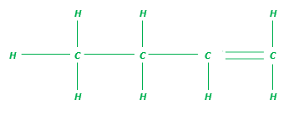[1]
- Ethene reacts with bromine water. What type of reaction is this? Include an equation showing the structures of the reactants and products. (3)
Addition reaction [1]
Correct displayed formula for: reactants [1], products [1]
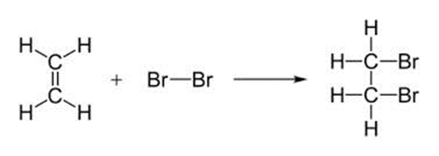
- Complete combustion of alkanes and alkenes produces carbon dioxide and water. What type of reaction is this? Include a balanced symbol equation for the complete combustion of propane. (3)
Oxidation [1]
C₃H₈ + 5O₂ → 3CO₂ + 4H₂O [2]

D. Polymers: Addition polymerisation and condensation polymerisation (HT)

- Explain what happens during addition polymerisation. (3)
Many small molecules (monomers) [1] join together [1] to make very large molecules (polymers) [1]

- Below is the monomer vinyl chloride. Draw the structural formula for the addition polymer it will make and show the repeating unit. (4)

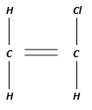
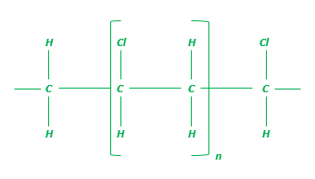
Correct sequencing of chlorines [1]
Correctly labelled repeating unit [1]
Correct use of n [1]
Spare bonds at end of structure [1] this mark is lost if H appears both ends

- (HT) Explain what happens during condensation polymerization. (3)
Monomers with functional groups [1] join together [1] losing small molecules [1]

- (HT) Propane diol polymerises with butanedioc acid to produce a polyester. Explain, using a symbol equation, how these monomers produce a condensation polymer (polyester). (3)

Propane diol HO – CH₂ – CH₂ – CH₂ – OH

Butanedioc acid HOOC – CH₂ - CH₂ –COOH

Correct repeating unit [1]
Correct reactants and water as a product [1]
Correct use of n [1]

- Describe problems associated with polymers. (4)
Maximum of 4 from:
Non-biodegradable [1] so persist in landfill sites [1]
Toxic gases can be produced when combusted [1]
When recycled the different types must be separated [1]
Made from fractions of crude oil, a finite resource [1]
E. Polymers: DNA and other naturally occurring polymers
- DNA is a polymer. Explain why. (2)
Made from repeating monomers [1] nucleotides [1]

- Name the monomers found in the naturally occurring polymers starch and protein. (3)
Starch – sugars [1]; proteins – amino acids [1]
F. Reactions of alcohols and carboxylic acids
- A student carried out an experiment to investigate the temperature rise produced in a known mass of water by combusting ethanol and pentanol.
  - Describe and explain the results the student would expect to see. Identify two control variables for the experiment. (4)
Pentanol will raise the temperature more [1] as it has a longer chain [1]
Any two from:
Same volume water [1] same mass of fuel burnt [1] or calculate per gram of fuel [1] same distance between top of flame and water [1] same container for the water [1] same starting temperature for the water [1] any sensible

  - Explain why the results may be lower than expected. (3)
Any three from:
Heat lost to surroundings [1] Incomplete combustion [1] Height of flame [1]
Air movement [1] Evaporation of alcohol [1]

- Ethanol C₂H₅OH is made during fermentation. Draw the structural formula of ethanol, describe the conditions needed for fermentation and explain why one of the conditions is the absence of oxygen. (6)

0 marks | Level 1 (1–2 marks) | Level 2 (3–4 marks) | Level 3 (5–6 marks)
No relevant content | 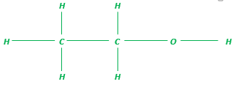  OR  Between 25^{O}C and 45^{O}C/yeast/water  OR  Ethanol will oxidise to ethanoic acid | Two of the relevant pieces of information. | All three relevant pieces of information.

- Draw the structure of propanoic acid and indicate the functional group. (3)
Correct number of carbon atoms [1]
Correct number of hydrogen atoms [1]

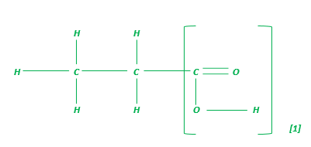
- Describe what you would see if calcium carbonate was added to propanoic acid and compare this to the reaction of calcium carbonate with nitric acid. Explain the difference in the reactions. (6)

0 marks | Level 1 (1–2 marks) | Level 2 (3–4 marks) | Level 3 (5–6 marks)
No relevant content | Bubbles of gas or carbon dioxide given off  OR  Correct identification of propanoic acid as a weak acid and nitric acid as a strong acid  OR  Correct explanation of greater ionisation in nitric acid/ORA | Two of the relevant pieces of information. | All three relevant pieces of information.

G. Nanoparticles: Sizes of particles and their properties, uses of nanoparticles
- How many nanometres make up 1 millimetre? (1)
1000000
2. What is a nanoparticle? (1)
Structures that are 1–100 nm in size

3. Explain why nanoparticles would make very efficient catalysts. (2)
Nanoparticles may have properties different from those for the same materials in bulk because of their high surface area to volume ratio (1) which means they are often able to react very quickly (1) high surface area to volume ratio (1)

4. Describe one social and one economic benefit of nanoscience. (2)
Social benefits: Nanoscience brings us useful products such as new drug delivery systems, better sports equipment, invisible sunblock creams.
Economic benefits: Nanoscience brings financial gain to the companies that make useful products from substances made up of nanoparticles.

1 mark for social benefit and 1 mark for economic benefit

- Calculate the surface area to volume ratio of the following cube. (3)
3cm

Volume = l x b x h = 3 x 3 x 3 = 27 [1] cm³ [1]
Surface area = 6 x (l x b) = 6 x (3 x 3) = 54 [1] cm² [1]
Surface area: volume = 54:27 = 2:1 [1]

